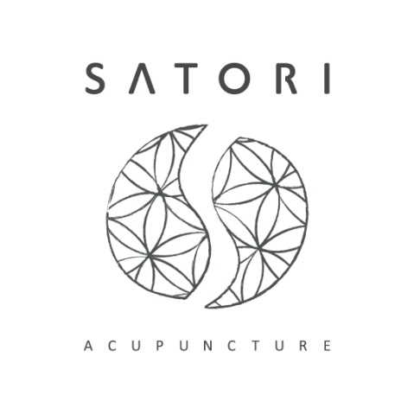
943 Finchley Road Golders Green London NW11 7PE
Satoriacutherapy.com 07840651212 deb@satoriacupuncture.co.uk

Privacy notice
Purpose of privacy notice
The processing of personal data is governed by the General Data Protection Regulation 2016/679 (GDPR). This legislation will replace current data privacy law, giving more rights to you as an individual and more obligations to organisations holding your personal data.
One of the rights is a right to be informed, which means I have to provide you with information about the way in which I use, share and store your personal information.
Personal Information
I need to collect personal information about your health and well-being in order to provide you with the best possible treatment plan and strategy. Your requesting treatment and our agreement to provide that care constitutes in law an (unwritten) contract. Where relevant I maintain records of the patient’s consent to treatment, or the consent of their next-of-kin in order to be able to prove that the patient (and/or parent/guardian/next of kin) has given informed consent to treatment.
I have a legitimate interest in collecting that information, in order to practice acupuncture effectively and safely. I keep a record of treatments given and details of progress of your case to enable me to: review the diagnosis, treatment strategy and planning; and to secure evidence in the event of criminal proceedings, civil litigation, an insurance claim or complaint.
I keep records of your contact information so that I can confirm your appointments or to update you on matters related to your medical care. This is your legitimate interest.
Provided I have your consent (this only needs to be verbal consent), I may occasionally send you individualised health information by email in the form of articles or advice and recommendations we discuss in treatment. You may withdraw this consent at any time – just let me know by any convenient method.
I use your GP’s name and address in the event that I need to contact your GP including in an emergency and because it is a mandatory requirement in the British Acupuncture Code of Professional Conduct. (https://www.acupuncture.org.uk)
You have the right to see what personal data of yours I hold, and you can also ask me to correct any factual errors. I am legally required to respond to any request from a client to see their personal data within a timescale of 30 days. I will ensure that I respond as soon as I possibly can to any reasonable request for access to personal records.
The following records are stored electronically on secure password protected applications:
• Your name, telephone number and email (if supplied)
• Email & text correspondence between us
• Invoices if requested
Your clinical records are recorded and stored on paper. I destroy any records kept in hard copy by shredding all such data when it is no longer required. I destroy any records kept electronically by permanently deleting such data when it is no longer required.
If I am ill and unable to treat you, I will pass any data to your new acupuncture practitioner should you wish me to do so. You will have to give me written permission before I can do this.
For further details about these rights please see the Information Commissioner’s Website at https://ico.org.uk/for-the-public/is-my-information-being-handled-correctly/
How long do I keep your personal data?
I keep patient records for a period of 7 years after your most recent appointment in accordance with the British Acupuncture Code of Professional Conduct. (https://www.acupuncture.org.uk/public-content/effectivepractice/bacc-professional-codes.html) After this period you can ask me to delete your records if you wish. Otherwise, I will retain your records indefinitely in order to provide the best possible care should you wish to see me at a future date.
Sharing your personal data
I will never share your information with anyone who does not have a legal right of access without your written consent. I will do everything I can to make sure that the only people who can access that data have a genuine need to do so. This is relevant in the case of my practice if a referral to another health professional is necessary to help you receive the most appropriate treatment. In this case I would ask your permission to share clinical information
Your personal data will be treated as strictly confidential, and will only be shared:
- with named third parties with your explicit consent;
- with the relevant authority, if necessary for compliance with a legal investigation or obligation;
- with your doctor, local authority or the police if necessary to protect your or another person’s life;
- With my regulatory body, the British Acupuncture Council, or my insurance company in the event of a complaint or claim being brought against me.
If you feel that I am mishandling your personal data in some way, you have the right to complain. Please first raise your concern with me, as I hope I will be able deal with any concerns you might have. However, you can also raise a concern directly with the Information Commissioner’s Office on https://ico.org.uk/concerns/
Website:
I use website cookies to improve user experience of the website by enabling the website to 'remember' users. My website search is powered by Squarespace. Search queries and results are logged anonymously to help improve the website and search functionality. No user-specific data is collected. For further details about your rights and your personal data please see the Information Commissioner’s Website at https://ico.org.uk/for-the-public/personal-information/sharing-my-info/ If you wish to contact the Information Commissioners Office Tel: 0303 123 1113, via email https://ico.org.uk/global/contact-us/email/ or at the Information Commissioner's Office, Wycliffe House, Water Lane, Wilmslow, Cheshire. SK9 5AF.

